CSCI 5380
Network Virtualization and Orchestration

Lab 1
Server Environment

University of Colorado Boulder
Department of Computer Science

Professor Levi Perigo, Ph.D.

Server Installation
- Each student is assigned an individual server for this course (see below).
- Find the server (labelled ADV. NGN-#) assigned to you, and label it with your name.
- Connect your assigned server to the VPN switch located in the last rack (rack having Dell servers) for Internet/VPN access. Please follow instructions in “OpenVPN Installation Instructions.docx” for assigning static IP and setting up VPN for your assigned server.

Student Name | Server Label
Student 1 | ADV. NGN - 1
Student 2 | ADV. NGN – 2
Student 3 | ADV. NGN – 3
Student 4 | ADV. NGN – 4
Student 5 | ADV. NGN – 5

Objective – OpenStack installation on Linux server
- The final goal of this objective is to install OpenStack on your server.
Start by installing a suitable Linux flavor on your server. Make sure the flavor and version you select is supported by OpenStack. Feel free to follow this guide:
https://docs.openstack.org/devstack/latest/.
- Once the base OS is installed, proceed to install OpenStack on the server. Keep in mind that the OpenStack instances need to speak to the Internet.
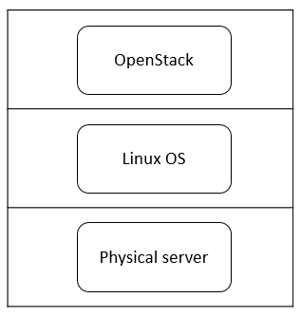
Figure 1. Final goal of Objective 1

- Paste the screenshots of successful installation of OpenStack on your assigned server. [100 points]
I used the Campus VM (VM1) to deploy the OpenStack –
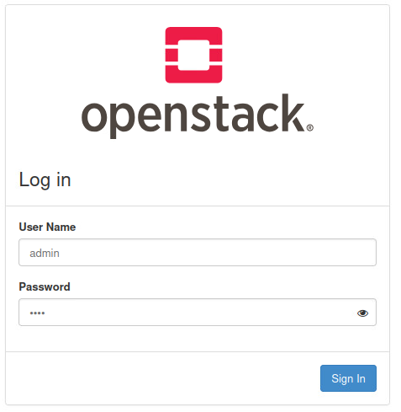
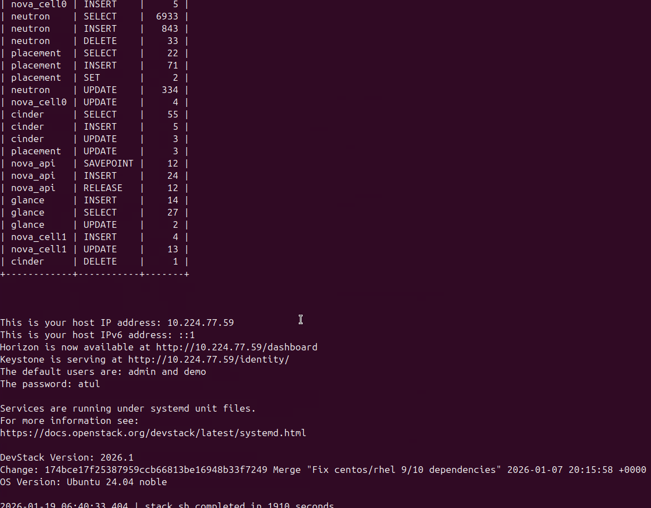
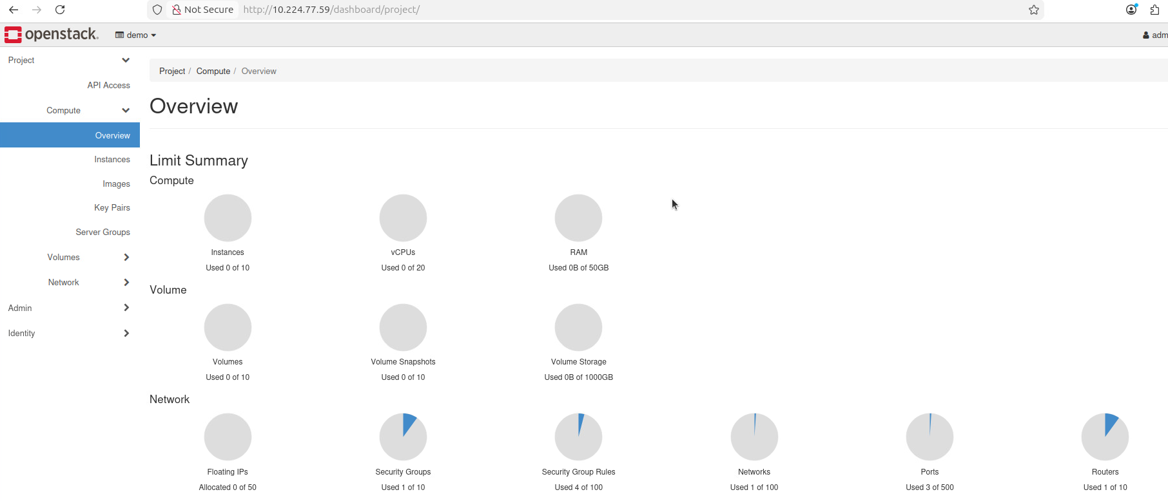

Total Score = ___ /100

